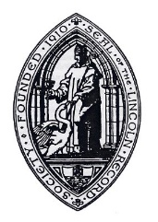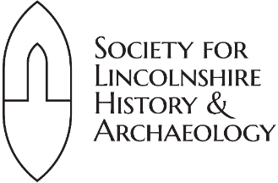

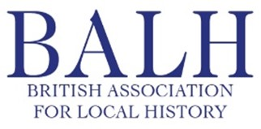

***Untold stories: new research on the city, county and historic diocese of Lincoln*,**

**Lincoln College, Monks Road, Lincoln**

**21 September 2024**

This wide-ranging day conference provides delegates with the opportunity to learn about recent research discoveries concerning primary source materials produced in or about aspects of life in the extensive city, county and historic Diocese of Lincoln.

*The conference is jointly organised by the British Association for Local History, Lincoln Record Society and the Society for Lincolnshire History & Archaeology.*

For booking information, please see:

[**https://www.eventbrite.co.uk/e/untold-stories-conference-tickets-932370072987**](https://www.eventbrite.co.uk/e/untold-stories-conference-tickets-932370072987)

**Indicative schedule**

**9.30-10.00 Tea/Coffee and registration**

**10.00 Welcome and introduction**

**10.05-11.30 Documenting the medieval Diocese of Lincoln**

Kathryn Dutton, ‘Editing the Kirkstead Abbey cartulary: the perspective of underexplored local sources’

Owain Gardner, ‘ Professor Joseph Goering – our debt to him for the future of the study of Robert Grosseteste, Bishop of Lincoln 1235–1253’

Jessica Holt, ‘Anglo-papal tensions: clerical appointments and patronage networks as depicted in the registers of Bishop Thomas Bek of Lincoln (1342-1347)’

**11.30-11.50 Coffee break**

**11.50-12.40 Regulating behaviour in the early-modern Diocese of Lincoln**

Brian Hodgkinson, ‘“To the fatherless chyldren at sanct kateryns wyth owt the barres off Lincoln, xxd”: investigating testators' charitable giving in Lincolnshire fenland districts, 1520-40’

Martin Roberts, ‘Ecclesiastical judges and the importance of emotion: Lincoln’s Audience Court and further dismantling historiographical orthodoxies around institutional efforts to restrain illicit sexual conduct’

**12.40-1.30 Lunch**

**1.30-2.45 Surveying people and property over space and time**

Jenne Pape, '”The Surveighe of the Mannour of Toynton” - life on the fen edge in the early years of the seventeenth century’

Mike Rogers, ‘Parliamentary surveys of the county and diocese of Lincoln, 1647-1660’

Shirley Brook, ‘Exploring social and cultural history through decorative architectural features. A case study of late-Victorian and Edwardian tiled entrances in Lincoln suburban houses’

**2.45-3.05 - Refreshments**

**3.05-4.25 – Life stories in early- and later-modern Lincolnshire**

Thomas Brown-Warr, ‘Geography and poll books: the political distribution of voters during the Lincolnshire by-election of 1721’

Martin Watkinson, 'The early memoirs of William Smith Hesleden (1774-1854), solicitor and antiquarian of Barton-upon-Humber'.

Jack Rhoden *et al*., ‘Lincoln Diocesan Training College: untold stories from its early students’

**4.25-4.30 – Closing remarks**